
KS1 Children- We would like our children to pledge that they will read at home for 10 minutes a day.
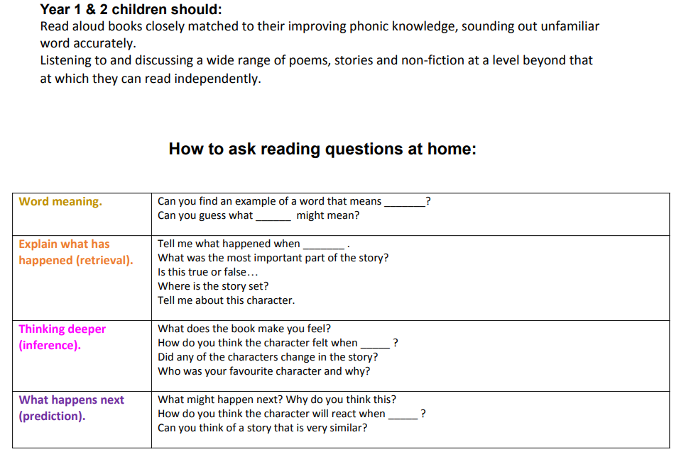

KS2 Children- We would like our children to pledge that they will read at home for 10 minutes a day.


