
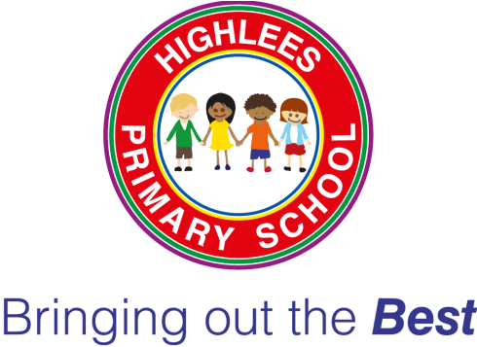
HIGHLEES PRIMARY SCHOOL
Parents’ questionnaire results
March 2018

 | Strongly Agree | Agree | Disagree | Strongly Disagree
- My child is happy at this school. | 57% | 22% | 5% | 0%
- My child feels safe at this school. | 58% | 37% | 5% | 4%
- My child makes good progress at this school. | 55% | 45% | 0% | 0%
- My child is well looked after at this school. | 56% | 42% | 2% | 0%
- My child is taught well at this school. | 52% | 46% | 2% | 0%
- My child receives appropriate homework for their age. | 43% | 47% | 8% | 2%
- This school makes sure its pupils are well behaved. | 45% | 45% | 10% | 0%
- This school deals effectively with bullying (including name calling, cyber-bullying, racist and homophobic bullying). | 38% | 49% | 11% | 2%
- My child enjoys the curriculum offered at this school | 47% | 53% | 0% | 0%
- My child is offered exciting experiences (after school clubs, trips, visitors etc.) | 46% | 47% | 5% | 2%
- The school is well led and managed. | 49% | 51% | 4% | 0%
- This school responds well to any concerns I raise. | 52% | 44% | 4% | 0%
- I receive valuable information from the school about my child’s progress. | 52% | 47% | 1% | 0%
- Would you recommend this school to another parent? | Yes 90% |  | No 10%

(61 questionnaires were completed. Not all questions were answered on every questionnaire)

We asked Parents to answer the following questions:
What do you like most about our school?

- “Homework club.”
- “Teaching methods.”
- “Promotes good behaviour.”
- “Knowing our son is achieving and doing well.”
- “The staff are brilliant and help the school to feel like a real community.”
- “Good school management.”
- “Teachers, especially Ms. Carcas who is very helpful.”
- “Communication and parent/school relationship”
- “Good teaching and support to children”.
- “My son loves coming to school, he is happy.”
- “My daughter is extremely happy about everything at school. She loves the clubs as well.”
- “Very well prepared teachers.”
- “King, caring staff.”
- “I like how my girl is treated and her progress.”
- “Friendly staff.”
- “The teachers are very nice.”
- “Lots of trips and school events,”
- “School dinners.”
- “It’s a happy place and the staff are all helpful.”
- “Great teacher/parent contact.”

How can we make our school better?

- “Stop bullying.”
- “More easy lessons.”
- “More homework.”
- “Get more parking spaces.”
- “Football pitch for kids.”
- “Teach languages.”
- “More school trips.”
- “Encourage children to resolve social interactions.”
- “Be more organised and plan ahead a few weeks with things like parent evenings so parents can get time off work.”
- “Reading books can be too easy.”
- “Bullying needs to be listened to more from pupils and dealt with a bit more seriously.
- “Improve food and online menu ordering.”
- “More after school clubs especially football.”
- “More ice-cream”
- “A lot of things.”
- “Some books about the techniques of learning would be helpful to help with homework.”
- “More playground equipment.”
- “More male teachers.”

